**KABARAK UNIVERSITY**



**SCHOOL OF SCIENCE ENGINEERING AND TECHNOLOGY**

**DEPARTMENT OF COMPUTER SCIENCE AND IT**

**EMPLOYEE MANAGEMENT SYSTEM**

**IT PROJECT**

**PRESENTED BY: JUSTINE BARASA**

**INTE/MG/3159/09/21**

**JANUARY-APRIL, 2025**

**DECLARATION**

I hereby declare that this proposal on Employee management systemsubmitted to School of Science Engineering and Technology, Kabarak University for the partial fulfillment of the requirement award of Bachelor of Information Technology is as a result of my original work and to the best of my knowledge has not been presented for the award of degree in IT in this institution.

JUSTINE BARASA

Sign……………………………….……………….……………….……………….…………….

Date……………………………….……………….……………….……………….…………….

**DEDICATION**

I dedicate this proposal to God, whose guidance and blessings make all things possible. I also dedicate every who has provided the resources for me. Additionally, the project aims to provide a comprehensive solution for managing employee data, including functionalities for employee records, attendance tracking, payroll management, and performance evaluation. I have ensured that the system adheres to best practices in software development and meets the requirements specified for effective and efficient employee management.

**RECOMMENDATION**

I highly recommend the implementation of the Standalone Employee Management System for organizations seeking to streamline and enhance their employee management processes. This system offers a comprehensive suite of features, including employee record maintenance, attendance tracking, payroll management, and performance evaluation, all integrated into a user-friendly interface. By automating and centralizing these critical functions, the system improves accuracy, efficiency, and accessibility of employee information, thereby reducing administrative burden and enabling better decision-making. The system is designed with best practices in software development, ensuring reliability, security, and scalability to meet the needs of growing organizations. Adopting this system will not only enhance operational efficiency but also support better workforce management and organizational productivity. The system includes tools for conducting performance evaluations, enabling managers to systematically assess and document employee performance. This feature supports the creation of a performance-driven culture by providing clear metrics and feedback mechanisms. Employees receive structured and timely feedback, which is crucial for their professional development and alignment with organizational goals. The user interface of the Standalone Employee Management System is designed with the end-user in mind. It offers an intuitive, easy-to-navigate experience that minimizes the learning curve and enhances user engagement. Whether accessed by HR professionals, managers, or employees, the system provides a seamless interaction experience that fosters productivity and user satisfaction

Sign……………………………….……………….……………….……………….…………….

Date……………………………….……………….……………….……………….…………….

**SUPERVISOR:** **Dr ANDREW KIPKEBUT.**

**ACKNOWLEDGEMENT**

I would like to extend my sincere gratitude to everyone who has contributed to the successful development and implementation of the Employee Management System. This project would not have been possible without the support, guidance, and dedication on numerous individuals and organizations.

Second, I would like to express my sincere gratitude to my supervisor, Simon Ruoro, for the continuous support, guidance, and encouragement throughout the course of this research. Your invaluable insights and constructive feedback have been instrumental in shaping this project.

I would also like to thank Kabarak University for providing the resources and environment necessary for the completion of this study. l thanks to the faculty and staff of the IT department for their assistance and support.

My deepest appreciation goes to my colleagues and friends, for their constant support, brainstorming sessions, and for being a source of motivation and inspiration.

I am immensely grateful to the participants of this study, whose cooperation and willingness to share their experiences and data made this research possible.

Finally, I would like to extend my heartfelt gratitude to my family for their unwavering support and encouragement. Your belief in me and your patience have been my greatest strength throughout this journey.

Thank you all for your contributions and support, which have been crucial to the successful completion of this project.

**ABSTRACT**

An Employee Management System is a comprehensive software solution designed to streamline and optimize various Human Resources and administrative tasks within an organization. It serves as a centralized platform for managing employee data, tracking attendance and time, processing payroll, conducting performance evaluations, handling recruitment and onboarding, managing leave and absences, administering benefits, and providing employee self-service functionalities. By automating routine tasks and facilitating seamless data integration across departments, an EMS enhances organizational efficiency, accuracy, and productivity while ensuring compliance with labor laws and regulations.

This project aims to develop a standalone Employee Management System to enhance the efficiency and accuracy of human resource management processes within organizations. The EMS is designed to address key administrative challenges such as employee record-keeping, attendance tracking, performance evaluation, and payroll management. Utilizing a secure and user-friendly interface, the system operates independently without the need for continuous internet connectivity, ensuring data integrity and accessibility in various operational environments.

Security and scalability are key considerations in the design of the Standalone Employee Management System. Robust security protocols protect sensitive employee data from unauthorized access, ensuring compliance with data privacy regulations. The system employs advanced encryption techniques and access control mechanisms to safeguard data integrity and confidentiality. Furthermore, the EMS is scalable, capable of accommodating the growing needs of organizations of varying sizes without compromising performance. The scalable architecture ensures that the system can handle an increasing number of users and data volumes, making it suitable for both small businesses and large enterprises.The Employee Management System is a comprehensive solution that addresses the multifaceted needs of human resource management. By automating and integrating critical HR functions such as attendance tracking, payroll processing, and performance evaluation, the EMS significantly enhances operational efficiency, accuracy, and strategic decision-making. Its secure, user-friendly, and scalable design ensures that organizations can effectively manage their workforce, drive employee engagement, and achieve sustainable growth.

Contents

**1.1 Introduction** 11

**1.2 Background to the study** 11

**1.2.1. Advantages of EMS** 13

**1.3 Statement of the problem** 13

**Significance of statement of problem** 14

**1.4 Objectives** 15

**1.4.1 Main Objectives** 15

**1.4.2 Specific Objectives** 15

**1.5 Research Questions** 15

**1.6 Significant of the Study** 15

**1.7 Scope and Limitation of the Study** 16

**1.7.1 Scope of the study** 16

**1.7.2 Limitation of the study** 17

**LITERATURE REVIEW** 18

2.1 Introduction 19

**2.2. Automate Employee Record Maintenance** 19

**2.3 Streamline Attendance Tracking** 19

**2.4 Performance Evaluation and Reporting** 20

**2.5 Concept Map / Conceptual Diagram** 20

**Key concept** 20

**Relationship** 21

**Diagram** 21

**RESEARCH DESIGN AND METHODOLOGY** 23

**3.1 Introduction** 23

**3.2 Research Design Methods** 23

**3.2.1 Development Methodology** 24

**3.3 Data Collection Used** 24

**3.4 System Analysis and Design** 25

**3.4.1 System Analysis** 25

**3.5. Requirements Analysis** 26

**3.6. Feasibility Study** 27

**.3.7. System Modelling** 28

**Data Flow Diagram** 29

**Entity-Relationship Diagram (ERD)** 30

**UML Diagrams** 31

**Use case Diagram** 32

**Class Diagram** 33

**Sequence Diagram** 35

**3.7.1 System Design** 35

**3.7.1.1 Architectural Design** 36

**Layered Architecture** 36

**3.7.1.2 Detailed Design** 37

**Component Design** 37

**Database Design** 37

**User Interface (UI) Design** 38

**User Interface (UI) Design** 38

**3.8 Research Ethics** 39

**Confidentiality** 39

**Anonymity** 39

**Informed Consent** 40

**Compliance with Ethical Standards** 40

**SYSTEM IMPLEMENTATION AND DESIGN** 41

**4.1 Introduction** 41

**4.2 Development Environment Setup** 41

**4.3 Implementation Steps** 42

**4.4 Testing and Quality Assurance** 49

**Testing Strategy** 49

**Quality Assurance (QA)** 50

**4.5 Deployment Plan** 51

**Deployment Approach** 51

**4.6 Go-Live Plan** 52

• **Post-Deployment Monitoring** 52

**4.7 Maintenance and Support** 53

**Maintenance Plan** 53

**User Support** 53

**4.8 Conclusion and Future Work** 54

**Key Achievements** 54

**Future Enhancements** 54

**REFERENCES** 55

**Appendices** 56

**Appendix I: Data Collection Tools** 56

**Appendix II: Project Schedule** 57

CHAPTER ONE

## **1.1 Introduction**

In today's dynamic business environment, effective management of human resources is crucial for organizational success. As companies grow, managing employee data, tracking attendance, processing payroll, and ensuring compliance with regulations become increasingly complex. Traditional manual methods and fragmented systems can lead to inefficiencies, errors, and compliance issues. Employee management systeM offers a comprehensive solution to these challenges by integrating various HR functions into a single, cohesive platform.

## **1.2 Background to the study**

Employee management practices have evolved significantly over the past few decades. Initially, organizations relied on manual record-keeping, which was time-consuming and prone to errors. With the advent of computer technology, basic software applications began to emerge, automating certain HR tasks. However, these early systems often lacked integration, requiring HR personnel to use multiple tools for different functions, resulting in data silos and inefficiencies.

The 1990s and early 2000s saw the rise of more sophisticated HR management systems (HRMS) and enterprise resource planning (ERP) solutions that offered integrated modules for various HR activities. While these systems provided significant improvements, they were often expensive, complex, and required extensive IT infrastructure and support, making them less accessible to small and medium-sized enterprises (SMEs).

The limitations of traditional employee management practices include data inaccuracies, inefficient workflows, and significant security risks.

Data Inconsistencies and Inaccuracies. In traditional employee management systems, data is often scattered across various formats and locations, leading to inconsistencies and inaccuracies. For instance, an employee's information might be updated in one system but not in another, resulting in conflicting records. These inconsistencies can lead to issues such as payroll errors, incorrect leave balances, and challenges in tracking employee performance accurately.

Time-Consuming Processes. Manual data entry and management are not only prone to errors but also consume a significant amount of time. HR personnel must spend substantial effort on routine tasks like updating records, processing payroll, and managing leave requests. This administrative burden reduces the time available for more strategic activities such as employee development and organizational planning.

Limited Accessibility and Collaboration. Traditional systems often make it difficult for HR teams and other stakeholders to access and share information efficiently. Physical records and disparate digital files can be challenging to locate and share, leading to delays and inefficiencies in HR processes. For instance, if a manager needs to access an employee's performance records, they might have to go through several steps to obtain the necessary information, hindering timely decision-making.

Security and Compliance Issues. Managing employee data manually or through unsecured digital means poses significant security risks. Sensitive information such as personal details, payroll data, and performance evaluations must be protected from unauthorized access and potential breaches. Traditional methods often lack the necessary security measures to ensure data protection. Moreover, organizations must comply with various labor laws and data protection regulations, and failing to do so can result in legal and financial consequences.

Emergence of Digital Solutions. In response to these challenges, digital solutions for employee management have emerged. These systems aim to centralize and automate HR processes, thereby addressing the inefficiencies and risks associated with traditional methods. An effective Employee Management System integrates various HR functions into a single platform, ensuring that data is consistent, accurate, and easily accessible. Such systems typically include features for employee data management, attendance tracking, payroll processing, leave management, performance evaluations, and compliance reporting.

### **1.2.1. Advantages of EMS**

EMS offers several advantages over traditional methods. By centralizing employee data, it ensures that all information is consistent and up-to-date across the organization. Automated workflows reduce the time and effort required for routine HR tasks, freeing up HR personnel to focus on strategic initiatives. Advanced security features protect sensitive data and help ensure compliance with relevant regulations. Additionally, a user-friendly interface makes it easier for all stakeholders to access and use the system effectively.

## **1.3 Statement of the problem**

In today's fast-paced business environment, effective management of human resources is crucial for the success of any organization. Traditional methods of managing employee information, including attendance records, performance evaluations, and personal details, are often inefficient and prone to errors.

These methods typically involve manual data entry and storage in physical files or disparate digital systems, leading to several key issues;

Data Inconsistency and Inaccuracy, Manual entry of employee data increases the likelihood of errors and inconsistencies. Different departments may maintain separate records, resulting in conflicting information and making it difficult to maintain a single, accurate source of truth.

Time-Consuming Processes, The administrative burden of managing employee records manually consumes significant time and resources. HR personnel must spend considerable effort on routine tasks such as updating records, calculating payroll, and managing leave requests, reducing their ability to focus on strategic activities.

Limited Accessibility and Security Risks, Physical records and fragmented digital systems pose accessibility challenges. Important information may not be readily available when needed, and there is a heightened risk of unauthorized access or data breaches due to inadequate security measures.

Inefficient Performance Tracking, Monitoring and evaluating employee performance using traditional methods is cumbersome and lacks real-time insights. This inefficiency hampers the ability to make timely decisions regarding promotions, training needs, and overall workforce development.

Given these challenges, there is a clear need for a robust, standalone employee management system that can streamline HR processes, enhance data accuracy, and improve overall efficiency.

**This project aims to develop such a system to address the following specific problems:**

Centralization of Employee Data,Creating a unified platform to store and manage all employee-related information, ensuring data consistency and easy accessibility.

Automation of HR Processes, Implementing automated workflows for routine HR tasks such as attendance tracking, payroll processing, and leave management, thereby reducing manual effort and minimizing errors.

Enhanced Security Measures: Integrating advanced security features to protect sensitive employee data and ensure compliance with data protection regulations.

## **Significance of statement of problem**

Addressing the inefficiencies in HR management through a standalone EMS will significantly enhance the productivity of HR departments by automating routine tasks and reducing errors. Improved data accuracy and security will facilitate better compliance with regulatory requirements and support strategic decision-making. For organizations operating in areas with limited internet access, a standalone system ensures continuous operational efficiency and data availability, thereby maintaining uninterrupted HR functions and supporting overall organizational success.

## **1.4 Objectives**

### **1.4.1 Main Objectives**

To centralize employee data management: Develop a unified platform that consolidates all employee-related information, ensuring data consistency and ease of access.

### **1.4.2 Specific Objectives**

**i.** Automate Employee Record Maintenance, develop a centralized database to store and manage comprehensive employee information.

**ii.** Streamline Attendance Tracking:Implement an automated attendance tracking system that accurately records employee attendance, reduces manual errors, and provides real-time monitoring and reporting capabilities.

**iii.** Performance Evaluation and Reporting, create tools to track and assess employee performance through performance reviews, key performance indicators (KPIs), and feedback systems.

## **1.5 Research Questions**

1. How can a standalone employee management system improve data consistency and accuracy in HR operations?
2. What are the key features required to automate HR processes effectively within an employee management system?
3. How can advanced security measures be integrated into the system to protect sensitive employee data and ensure regulatory compliance?

## **1.6 Significant of the Study**

The Employee Management System is a crucial tool for modern organizations, helping them efficiently manage their workforce. The significance of this study includes:

1. Improved Efficiency and Productivity, Employees can focus on productive tasks rather than paperwork.
2. Accurate Data Management and Accessibility, ensures accurate and real-time storage of employee data, reducing errors.
3. Enhanced Security and Confidentiality, secures sensitive employee data through authentication and role-based access.

Despite its benefits, implementing an Employee Management System comes with certain challenges:

1. Integration with Existing Systems – Many organizations have legacy HR systems that may not integrate easily with a new EMS.
2. User Adoption and Training – Employees and HR personnel may require training to fully utilize the system.
3. **S**ecurity Concerns – Handling sensitive employee data requires robust security measures to prevent cyber threats.

## **1.7 Scope and Limitation of the Study**

### **1.7.1 Scope of the study**

The scope of this study defines the boundaries within which the Employee Management System (EMS) is designed, developed, and evaluated. It includes:

**Research Boundaries**

The study focuses on the design, development, and implementation of an EMS tailored for organizations to manage employee records, attendance, payroll, and performance tracking.

The system will be developed using HTML, CSS, JavaScript for the frontend and Mongodb for the backend, ensuring a web-based, user-friendly platform.

**Geographical Scope**

The study is conducted within the context of organizations operating in particularly small to medium-sized businesses and government institutions.

The system can be adapted for use in various sectors, including corporate, government, and non-governmental organization.

**User Scope**

The system is intended for HR personnel, managers, and employees who will use it to manage records, track attendance, and process payroll.

Employees will have limited access to personal records, while administrators will have full control over the system.

### **1.7.2 Limitation of the study**

The limitations of the study define the constraints and challenges that may impact the development, implementation, or effectiveness of the system. These limitations may arise from technical, functional, or organizational factors.

**Limited Integration Capabilities**

Isolation from Other Systems: Being a standalone system, it will not easily integrate with other software applications (e.g., ERP systems, cloud-based services), potentially leading to data silos and manual data entry.

Lack of Real-Time Updates: The system will not support real-time updates across multiple devices or locations, which could be a limitation for organizations with remote workers or multiple offices.

**Scalability Constraints**

Fixed User and Data Capacity: The system may not be able to efficiently scale to accommodate a significant increase in the number of employees or data volume, limiting its use as the organization grows.

Limited Performance: As a standalone application, performance may degrade if used by more users than originally intended or if the amount of data stored becomes too large.

**Dependency on Local Resources**

Hardware Requirements: The system will depend on the local machine’s hardware, which may limit performance if the system requirements are not met.Data Backup and Recovery: Without cloud integration, data backup and recovery will rely on local solutions, which may be less reliable and more prone to data loss in case of hardware failure.

**CHAPTER TWO**

## **LITERATURE REVIEW**

## **2.1 Introduction**

In this chapter, we delve into the extensive body of research and scholarly work related to standalone employee systems. The primary goal of this literature review is to provide a comprehensive understanding of the existing knowledge, theoretical frameworks, and practical applications of such systems. By examining the historical development, current trends, and future directions of standalone employee systems, we aim to identify key themes, gaps, and opportunities that will inform the design and implementation of our proposed system.

This chapter is structured to cover various dimensions of standalone employee systems, including their technological underpinnings, functionality, benefits, and challenges. We begin with a historical overview, tracing the evolution of employee management systems from traditional, paper-based methods to contemporary, digital solutions. Next, we explore the different types of standalone employee systems, highlighting their features and capabilities.

## **2.2. Automate Employee Record Maintenance**

Developing a **centralized database** that securely stores and manages comprehensive employee information. Traditionally, organizations rely on paper records or spreadsheets, which are prone to data loss, redundancy, and inefficiencies. By implementing a centralized system, HR personnel can efficiently store and retrieve employee details such as personal information, job roles, salaries, and employment history. This automation minimizes paperwork, enhances data accuracy, and ensures quick access to employee records while maintaining strict security controls to prevent unauthorized access.

## **2.3 Streamline Attendance Tracking**

Implementing an **automated attendance system** that accurately records employee check-in and check-out times. Manual attendance tracking methods, such as registers and punch cards, are susceptible to errors, fraud, and inefficiencies. The EMS will eliminate these issues by using digital logins, biometric systems, or RFID-based tracking to record employee work hours in real time. Additionally, the system will generate **automated attendance reports,** allowing HR to monitor absenteeism, lateness, and overtime. Real-time alerts will notify management of irregular attendance patterns, ensuring better enforcement of attendance policies. This automation reduces manual errors, prevents time theft, and integrates seamlessly with payroll processing for accurate salary calculations.

## **2.4 Performance Evaluation and Reporting**

providing tools to track and assess employee performance. Employee evaluations are crucial for making informed decisions regarding promotions, rewards, and training. The EMS will incorporate **performance tracking features** such as **Key Performance Indicators (KPIs),** manager and peer reviews, work progress reports, and goal tracking. These tools will offer **real-time performance insights**, ensuring that evaluations are objective and data-driven. By generating automated performance reports, the system will help HR professionals and managers make informed decisions while also motivating employees to improve their efficiency and productivity.

## **2.5 Concept Map / Conceptual Diagram**

The **conceptual framework** for the **Employee Management System (EMS)** defines the relationship between the **key concepts, methodologies, and variables** that influence the system's development and functionality. This framework is essential in understanding how various components interact and contribute to achieving the objectives of the system.

## **Key concept**

Several key concepts derived from relevant theories and best practices in software engineering, database management, usability, and security are integral to this project. These include:

1. Employee Data Management – The concept of maintaining accurate and secure employee records using a centralized database. This ensures data integrity, consistency, and security, allowing authorized users to retrieve and manage employee information efficiently.
2. Performance Evaluation – A structured approach to assess employee performance using Key Performance Indicators (KPIs), feedback mechanisms, and automated reporting. This helps in promotions, rewards, and training recommendations.
3. Usability and User Experience (UX) – The system is designed to be user-friendly, with an intuitive interface for HR managers, employees, and administrators. Good UX practices improve efficiency and adoption rates.
4. Security Measures – Implementation of authentication, authorization, and encryption techniques to safeguard sensitive employee data from unauthorized access and cyber threats.

## **Relationship**

**Integration** - Ensuring seamless integration between various modules (e.g., payroll, attendance tracking, performance management) to maintain data consistency and accuracy.Utilizing APIs and middleware to enable interoperability with existing systems.

**User Experience** - Designing an intuitive user interface that facilitates easy access to different features. Conducting usability testing to gather feedback and make necessary adjustments.

**Scalability** - Developing a system architecture that can accommodate organizational growth and changing HR needs.Implementing scalable database solutions to handle increasing volumes of employee data.

**Security** - Integrating advanced security measures such as encryption, access controls, and audit trails to protect employee information.Ensuring the system complies with data protection regulations.

## **Diagram**

The conceptual diagram for the **Employee Management System** highlights how different modules work together to provide a seamless experience for managing employees. The system ensures data accuracy, automates repetitive tasks, and enhances efficiency in HR processes. Users interact with the system by making requests, and the system responds with relevant feedback, ensuring smooth operation and effective management of employee records, attendance, performance, payroll, and security.

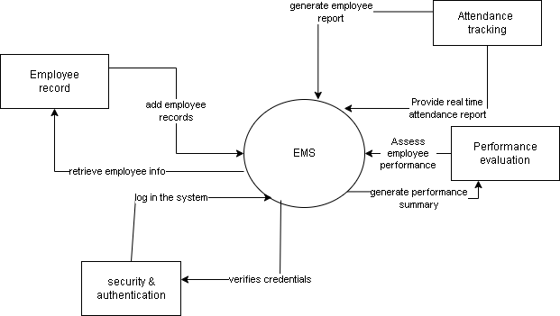

**CHAPTER THREE**

## **RESEARCH DESIGN AND METHODOLOGY**

## **3.1 Introduction**

This chapter outlines the research design and methodology used in developing the **Employee Management System**. It details the research approach, data collection methods, system development techniques, and the tools used to ensure the project meets its objectives. The chapter also explains how the research was structured to address the problem statement effectively while ensuring accuracy, reliability, and efficiency in system implementation.

The research design provides a framework for how data was gathered, analyzed, and applied in developing the system. Various methodologies, including software development models and data gathering techniques, were considered to ensure the system meets user requirements. Additionally, this chapter highlights the tools and technologies chosen for development, as well as the ethical considerations taken into account during the research and implementation phases.

By defining the methodology and research design, this chapter serves as a foundation for understanding how the Employee Management System was systematically developed and validated.

## **3.2 Research Design Methods**

The research design for this project is a combination of qualitative and quantitative methods. The qualitative aspect involves gathering detailed requirements from potential users through interviews and questionnaires, while the quantitative aspect involves analyzing the collected data to identify key features and functionalities needed for the system. This mixed-method approach ensures a comprehensive understanding of user needs and system requirements.

**Qualitative Methods**: Interviews and focus groups with potential users will be conducted to gather in-depth insights into their needs, preferences, and experiences with existing tour applications. This will inform the design and functionality of the new application. The qualitative data will provide rich, descriptive insights that can highlight areas for improvement and innovation.

**Quantitative Methods**: Surveys and usability tests will be used to collect measurable data on user satisfaction, usability, and the performance of the application. Statistical analysis will be performed to identify trends and patterns, providing a broad perspective on user experiences and the overall effectiveness of the application.

The combination of these methods ensures a holistic view of the user's interaction with the application, balancing detailed personal insights with broad statistical trends.

### **3.2.1 Development Methodology**

The development of the **Employee Management System (EMS)** followed a structured methodology to ensure efficiency, reliability, and scalability. A **Software Development Life Cycle (SDLC) model** was selected to guide the process, focusing on iterative development, continuous testing, and user feedback incorporation. Given the dynamic nature of the project requirements, the **Agile methodology** was adopted to allow flexibility in development, regular updates, and continuous user involvement.

#### **Agile Development Methodology**

Agile methodology was chosen because it promotes iterative development, ensuring that the system is built incrementally with continuous improvements based on user feedback. This approach allowed for early detection of potential issues, reduced project risks, and enhanced user satisfaction.

## **3.3 Data Collection Used**

To ensure the successful development of the **Employee Management System (EMS)**, various data collection methods were employed to gather relevant information. These methods were chosen to obtain accurate insights into system requirements, user needs, and operational challenges. The collected data guided the design, development, and implementation of the system.

#### **Interviews**

Interviews were conducted with HR personnel, administrators, and employees to gather firsthand insights into their challenges and expectations regarding employee management. Questions focused on current record-keeping methods, attendance tracking issues, and the need for automated performance evaluation. The feedback obtained helped in defining system features and functionalities.

#### **Questionnaires**

Structured questionnaires were distributed to potential system users to collect data on their preferred system functionalities, usability preferences, and pain points in the existing management processes. This method allowed for a broader perspective and facilitated quantitative analysis of user requirements.

#### **Observation**

Direct observation of existing employee management processes was carried out to understand workflows, inefficiencies, and areas that required automation. This helped in identifying repetitive manual tasks that the system could optimize, such as manual attendance logging and performance assessment procedures.

**Document Analysis**

Reviewing existing employee records and management documents to identify data fields and processes that need to be incorporated into the system.

## **3.4 System Analysis and Design**

This section focuses on analyzing the system requirements, conducting feasibility studies, and designing the system architecture and components to ensure efficient implementation of the **Employee Management System.**

### **3.4.1 System Analysis**

System analysis is a structured process of examining and defining the requirements and functionalities of the **Employee Management System (EMS).** This phase is crucial as it lays the foundation for designing and developing a system that meets the needs of stakeholders effectively. The analysis process involves gathering and analyzing requirements to ensure that the system aligns with the organization's goals.

#### **Requirements Gathering**

To collect the necessary requirements for the system, multiple techniques were used:

1. **Interviews:** Key stakeholders such as HR personnel, administrators, and employees were interviewed to understand their needs and expectations for the EMS. These discussions helped in identifying challenges faced in the current employee management process.
2. **Surveys and Questionnaires:** Structured questionnaires were distributed to employees and managers to collect insights on system features they would find useful. This method ensured data collection from a larger audience.
3. **Observation:** The current employee management processes were observed to identify inefficiencies, bottlenecks, and potential improvements that the EMS could address.
4. **Document Analysis:** Existing employee records, manuals, and HR policies were reviewed to determine essential data fields, workflows, and compliance requirements that needed to be incorporated into the system.

## **3.5. Requirements Analysis**

After gathering the requirements, an analysis was conducted to categorize and define the system's functionalities.

* **Functional Requirements:** These define what the system should do, including:

Employee registration, updating, and deletion.

Attendance tracking with automated time-stamping.

Performance evaluation and reporting.

Secure authentication and user role management.

* **Non-Functional Requirements:** These define how the system should perform, including:
  + 1. **Performance:** The system should handle multiple concurrent users efficiently.
    2. **Security:** User authentication and data encryption should be implemented to prevent unauthorized access.
    3. **Usability:** The system should have a user-friendly interface that is easy to navigate.
    4. **Scalability:** The system should be able to support future expansion, such as integrating new modules.

## **3.6. Feasibility Study**

A feasibility study was conducted to evaluate the viability of the **Employee Management System (EMS)** before development. This assessment ensured that the project could be successfully implemented within the available resources and organizational constraints.

#### **Technical Feasibility**

Technical feasibility assesses whether the necessary technology for the EMS is available and practical for implementation. The key considerations include:

1. **Availability of Development Tools -** The project utilizes widely available technologies such as **MongoDB, and Visual Studio Code (VS Code),** which are open-source and well-supported.
2. **Scalability and Performance -**MongoDB provides flexible and scalable database management, while Node.js ensures efficient backend operations, making the system capable of handling increasing data loads.
3. **Integration with Existing Systems -** The system can be integrated with existing **HR management tools.**
4. **Security Measures -** The system is designed with security in mind, **authentication, role-based access control (RBAC), and encryption mechanisms** to protect sensitive employee data.

#### **Economic Feasibility**

Economic feasibility evaluates whether the project is cost-effective and provides financial benefits compared to the costs incurred during development and maintenance.

1. **Development Costs -** Since the project is built using **open-source technologies**, there are no licensing costs for development tools, frameworks, or databases.
2. **Operational Costs -** The system can be hosted on a **local server or cloud platform (e.g., AWS, Azure)** based on the organization’s budget. Cloud hosting offers flexibility but may incur additional costs.
3. **Cost Savings -** The automation of employee management tasks (e.g., payroll, attendance tracking) reduces administrative overhead, leading to **long-term cost savings** for the organization.

#### **Operational Feasibility**

Operational feasibility determines whether the system will function effectively within the current organizational environment and meet the needs of stakeholders.

1. **User Adaptability -** The system is designed with a **user-friendly interface**, ensuring easy adoption by HR personnel, managers, and employees.
2. **Training and Support -** Minimal training will be required as the system provides **intuitive navigation and automated processes**, reducing the learning curve for users.
3. **Process Integration:** The EMS aligns with **existing HR workflows**, making it a seamless addition to the organization’s operations without significant disruptions.
4. **Legal and Compliance Considerations -** The system ensures **compliance with labor laws and data protection regulations** by securely handling employee records and payroll data.

## 

## **3.7. System Modelling**

System modeling is a crucial step in software development that helps visualize the structure, processes, and relationships within the **Employee Management System**. The following models were used to represent different aspects of the system.

**Data Flow Diagram**

Dataflow diagrams (DFDs) illustrate the flow of data within the system.

**. Context Diagram:** High-level view of the system interation

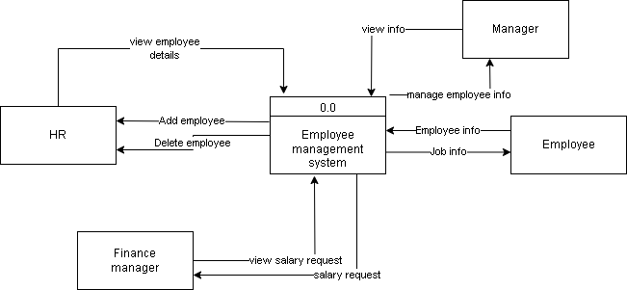

**Level 1 DFD:** Detailed view of the main processes within the system.

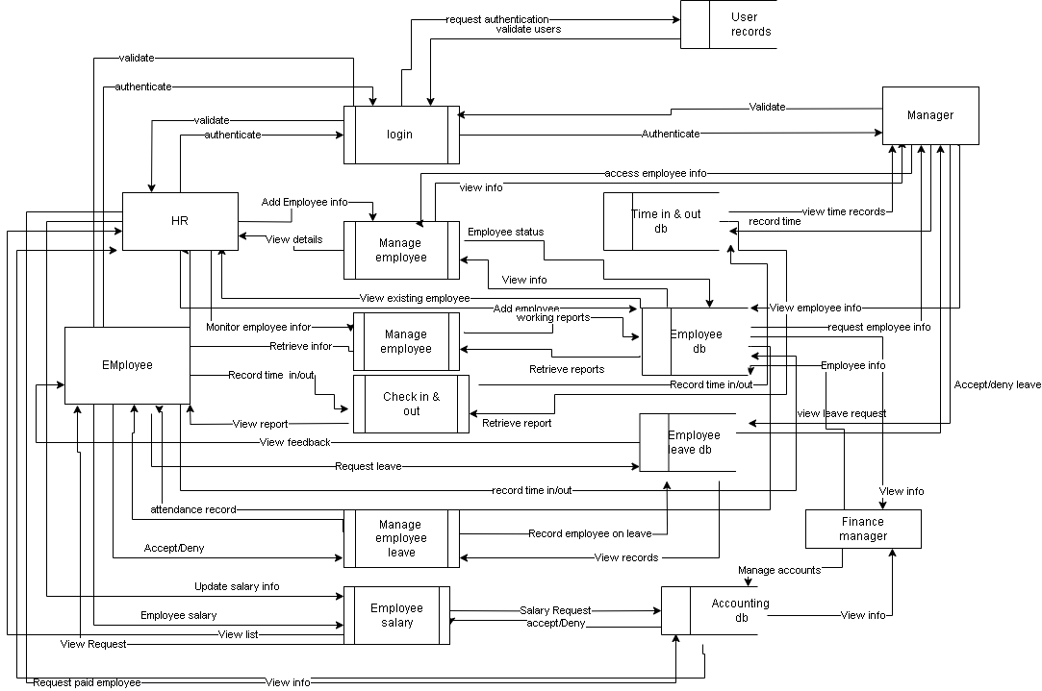

## **Entity-Relationship Diagram (ERD)**

The database design diagram of the Employee Management System is structured to efficiently store, retrieve, and manage data related to employees and their interactions within the organization.

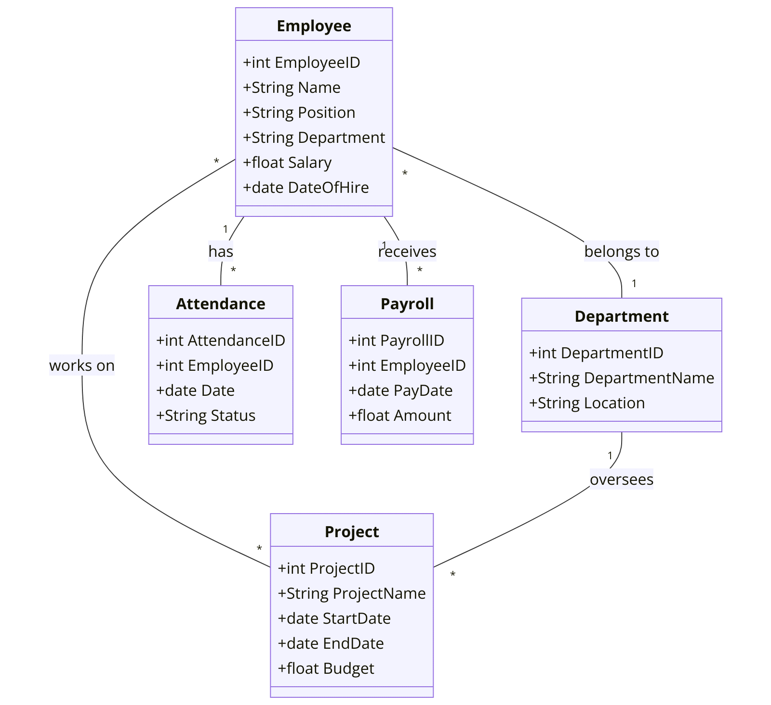

## **UML Diagrams**

UML (Unified Modeling Language) description for your Employee Management System project, focusing on its structure and behavior. Since you mentioned using MongoDB as the database, I’ll incorporate that into the design. This description includes an overview of key UML diagrams: Class Diagram, Use Case Diagram, and Sequence Diagram**.**

## **Use case Diagram**

|  |
| --- |
| **EMPLOYEE MANAGEMENT SYSTEM** |

## **Class Diagram**

The Class Diagram outlines the static structure of the Employee Management System, including key entities, their attributes, and relationships

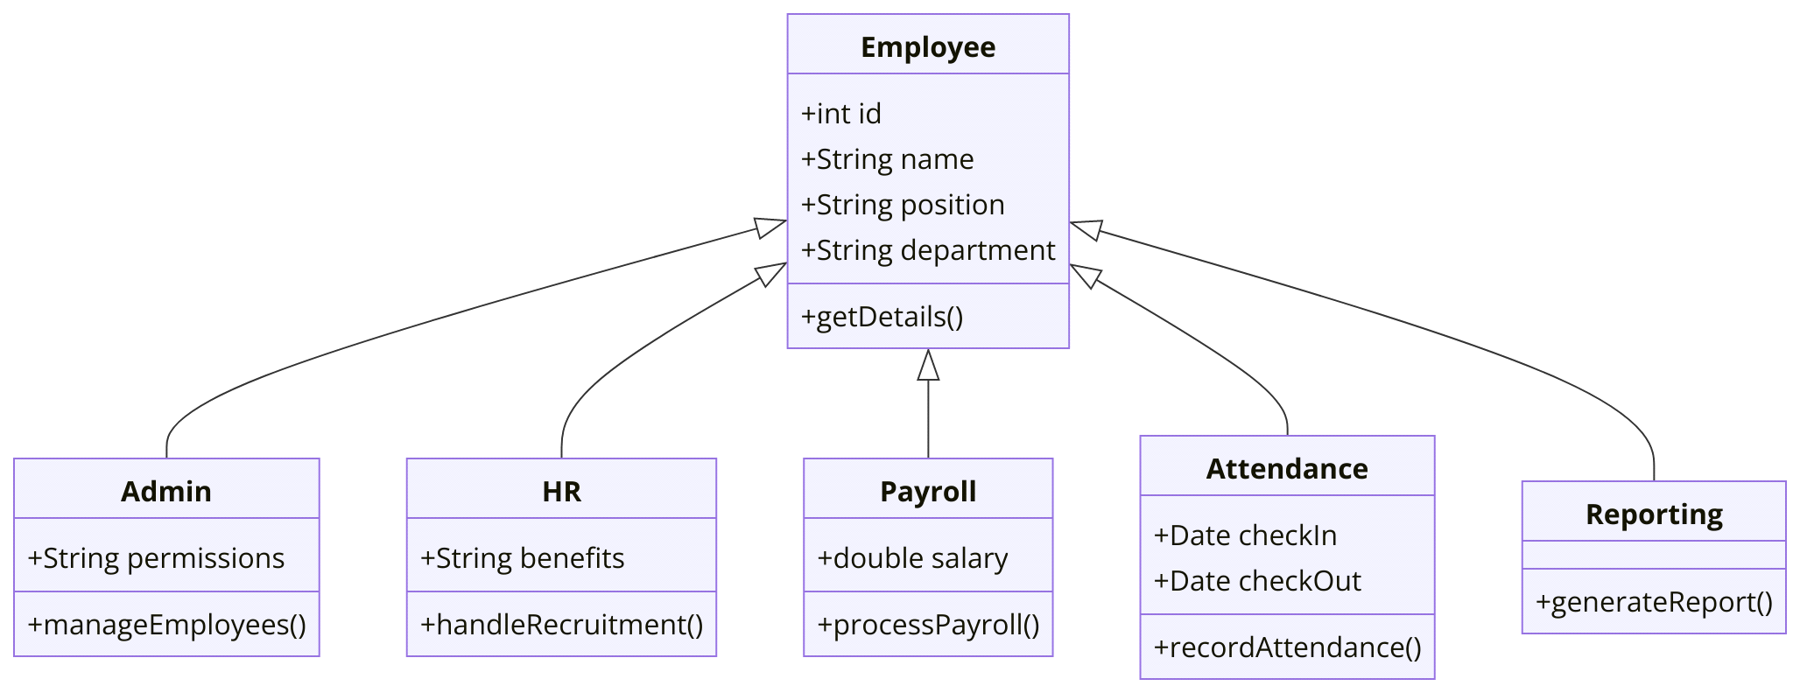

**Sequence Diagram**

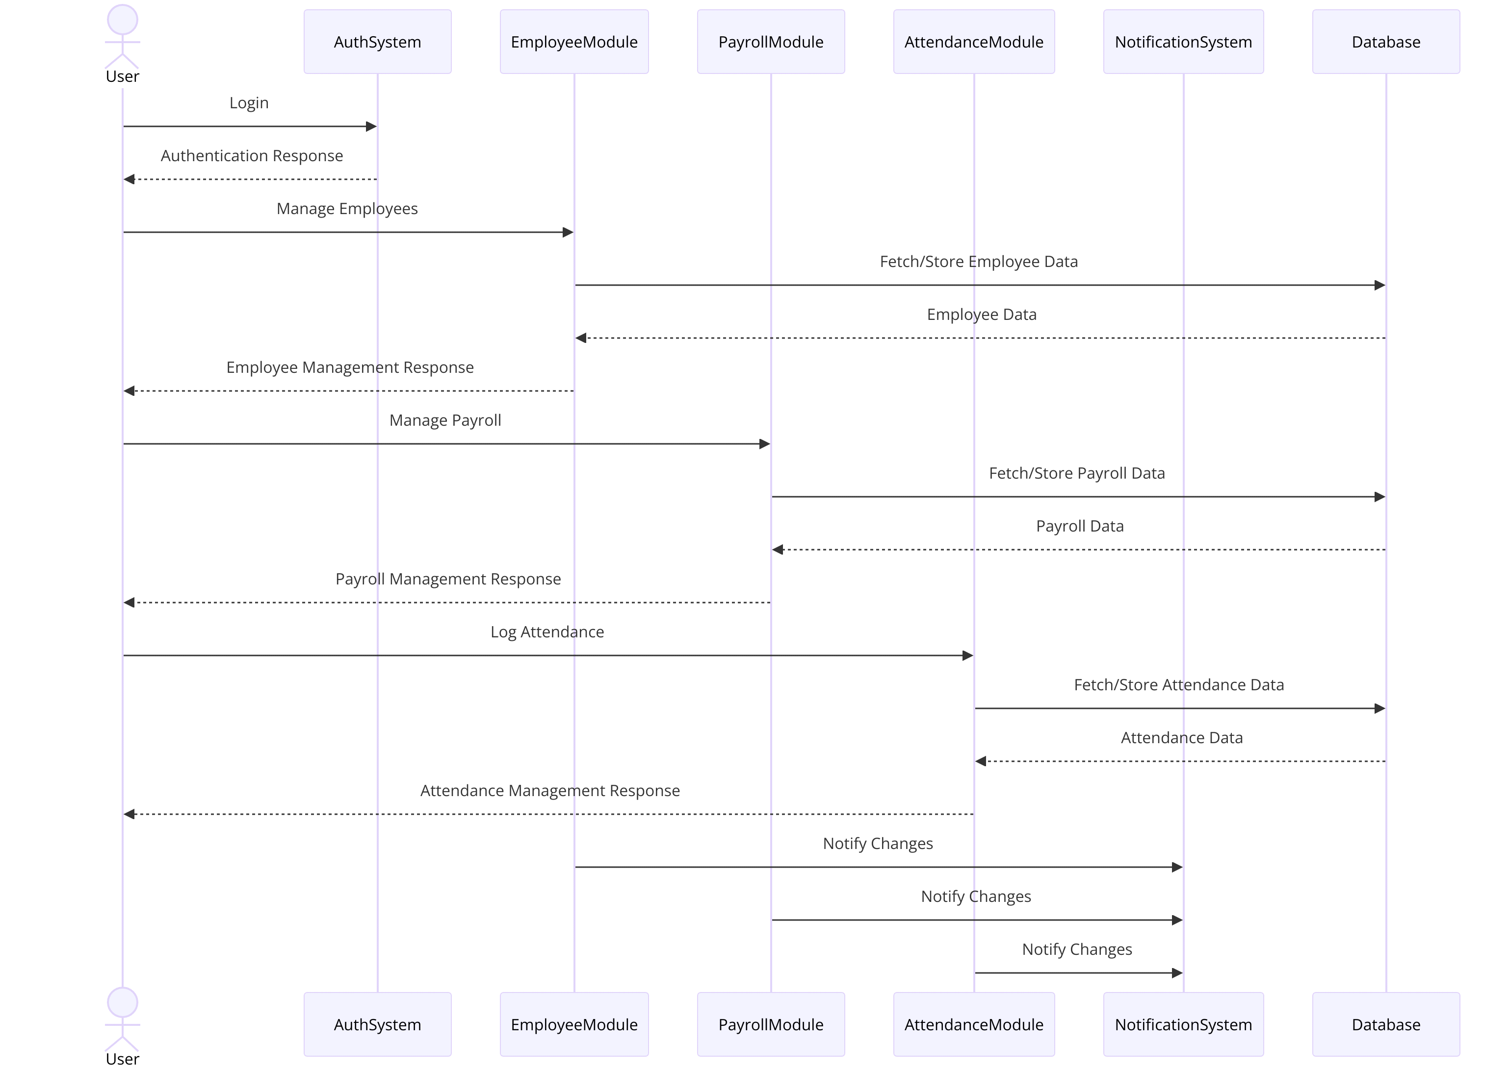

## **3.7.1 System Design**

The System Design phase defines how the Employee Management System will be structured and implemented based on the requirements identified during the System Analysis phase. This phase ensures that the system architecture, components, database, and user interface are well-planned for efficient functionality and scalability.

### **3.7.1.1 Architectural Design**

The architecture diagram of the Employee Management System is designed to illustrate the key components and their interactions within the system. This comprehensive system aims to streamline various HR functions, ensuring efficient management of employee-related processes.

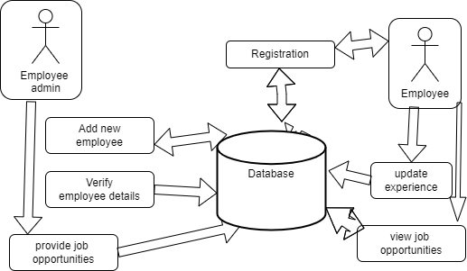

### **Layered Architecture**

The system follows a **three-tier architecture** to ensure separation of concerns:

1. **Presentation Layer (Frontend)** – User interface for employees, HR, and admins.
2. **Business Logic Layer** – Manages system logic, authentication, and processing requests.
3. **Data Access Layer (Database) –** Stores and retrieves employee records securely.

### **3.7.1.2 Detailed Design**

### **Component Design**

The EMS is divided into functional modules to ensure maintainability and efficiency:

1. **Authentication Module:** Handles user login and role-based access control.
2. **Employee Management Module:** Manages employee profiles, contracts, and roles.
3. **Attendance Module:** Records and tracks employee attendance.
4. **Payroll Module:** Computes employee salaries based on attendance and deductions.
5. **Performance Evaluation Module:** Assesses and tracks employee performance metrics.

### **Database Design**

The system uses **MongoDB** to store structured and unstructured employee data. The **database schema** consists of:

1. **Employee Collection:** Stores employee personal details, position, and contact information.
2. **Attendance Collection:** Logs employee check-in and check-out times.
3. **Performance Collection:** Tracks employee performance scores and feedback.

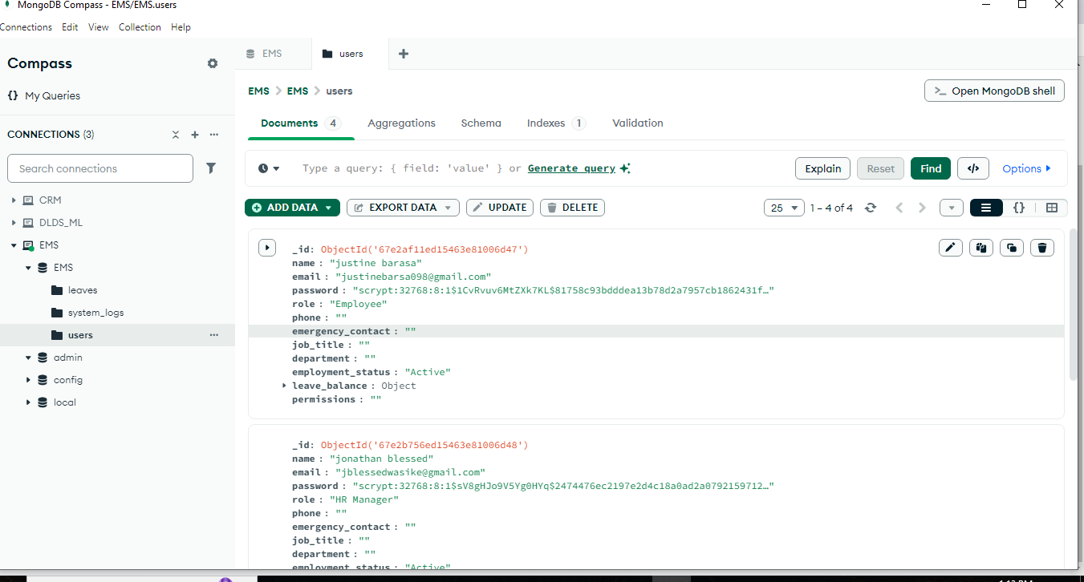

### **User Interface (UI) Design**

The UI is designed to provide a user-friendly experience for employees, HR personnel, and administrators.

1. **Login Page:** Secure authentication for different user roles.
2. **Dashboard:** Displays employee details, performance insights, and payroll summaries.
3. **Forms:** Interactive data entry for adding and updating employee records.
4. **Reports:** Generates downloadable reports for payroll, attendance, and performance tracking.

## **3.8 Research Ethics**

Research ethics ensure that the study is conducted in a responsible and ethical manner, particularly when dealing with human subjects. The development of the **Employee Management System** involves gathering data from employees, HR personnel, and other stakeholders. Therefore, ethical considerations such as **confidentiality, anonymity, and informed consent** must be upheld.

## **Confidentiality**

Confidentiality involves protecting sensitive employee and organizational data collected during the research process. The following measures will be implemented:

1. Ensuring that **personal and employment data** is securely stored and accessed only by authorized personnel.
2. Using **data encryption** and **access control** mechanisms to prevent unauthorized access.
3. Prohibiting the sharing of **sensitive company information** with third parties without permission.

## **Anonymity**

Anonymity ensures that the identity of participants remains undisclosed to protect their privacy. The system will implement the following:

1. **No personally identifiable information** will be collected unless necessary for system functionality.
2. Using **unique identifiers or pseudonyms** instead of real names when analyzing or presenting data.
3. Removing **personal details** from reports and research findings to prevent traceability.

## **Informed Consent**

Participants must be informed about the purpose of the research and voluntarily agree to provide their data. The following steps will be taken:

1. Providing a **clear explanation** of the study’s objectives, how the data will be used, and potential risks/benefits.
2. Ensuring participants **sign consent forms** before collecting their information.
3. Allowing participants to **withdraw from the study** at any time without penalties.

## **Compliance with Ethical Standards**

To ensure adherence to ethical guidelines, the research will follow:

1. **Institutional ethical policies** on data collection and protection.
2. **GDPR (General Data Protection Regulation) and Data Protection Act** principles where applicable.
3. Ethical approval from relevant authorities before conducting the study.

**4. CHAPTER FOUR**

## **SYSTEM IMPLEMENTATION AND DESIGN**

## **4.1 Introduction**

This chapter presents the implementation and deployment of the Employee Management System. It covers the coding process, testing strategies, and deployment procedures that mark the transition from system development to practical use. The chapter also discusses the tools and technologies used in the development phase, ensuring that the system functions as intended and meets the defined objectives.

## **4.2 Development Environment Setup**

**Software tool and Environment**

To develop the EMS, specific programming languages, frameworks, and tools were selected to ensure efficient development and deployment. The key tools used include:

1. Programming Language **-** Python
2. Database Management **–** MongoDB, A NoSQL database chosen for its scalability and flexibility in handling employee records.
3. Frontend Technologies **-** HTML, CSS, JavaScript – Used for designing an interactive and responsive user interface.
4. Git & GitHub – Version control.
5. Development Environment: Visual Studio Code (VS Code) – A powerful and lightweight code editor chosen for its extensive extensions, debugging capabilities, and Git integration.

**Development Environment Configuration**

Setting up the development environment involved the following steps:

1. **Installing VS Code** – Downloaded and configured VS Code with necessary extensions, including Prettier for code formatting, code quality checks, and MongoDB extension for database management.
2. **Configuring MongoDB** – Set up a local or cloud-based MongoDB database to store employee records, attendance logs, and performance data

## **4.3 Implementation Steps**

**Step by Step Implementation plan**

To ensure a smooth development process, the system was implemented in phases, breaking down the tasks into manageable modules.

#### **Timeline with Milestones**

The development process was divided into two main phases:

##### **1. Frontend Development**

**UI/UX Design**

Created wireframes and mockups for the employee dashboard, login pages, and admin dashboard.

Designed responsive UI layouts using HTML, CSS, and JavaScript.

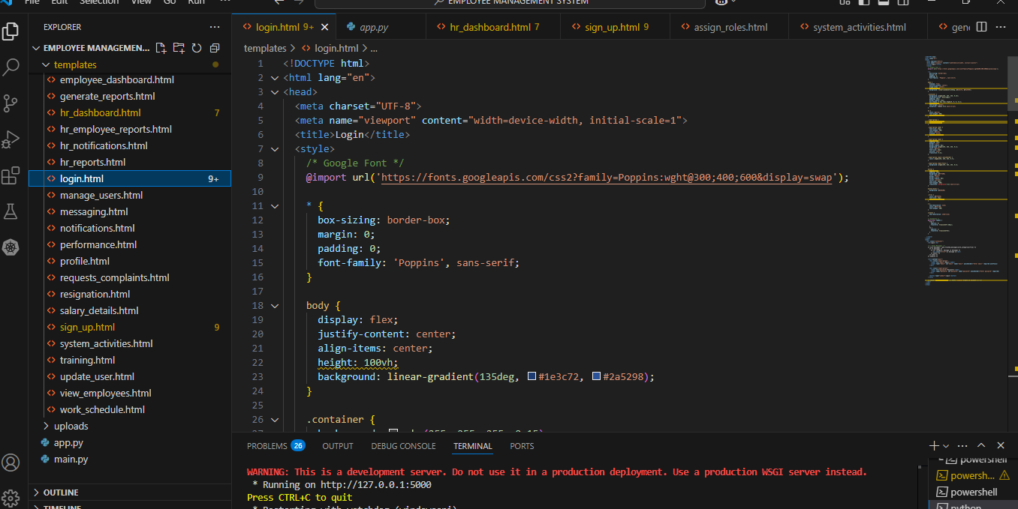

Sign up code

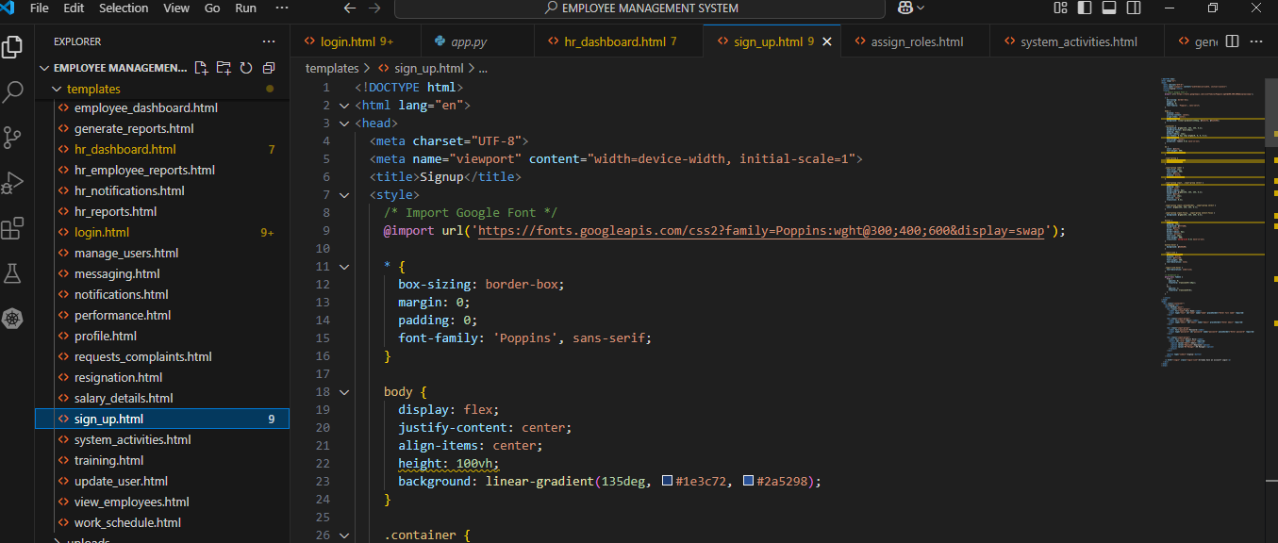

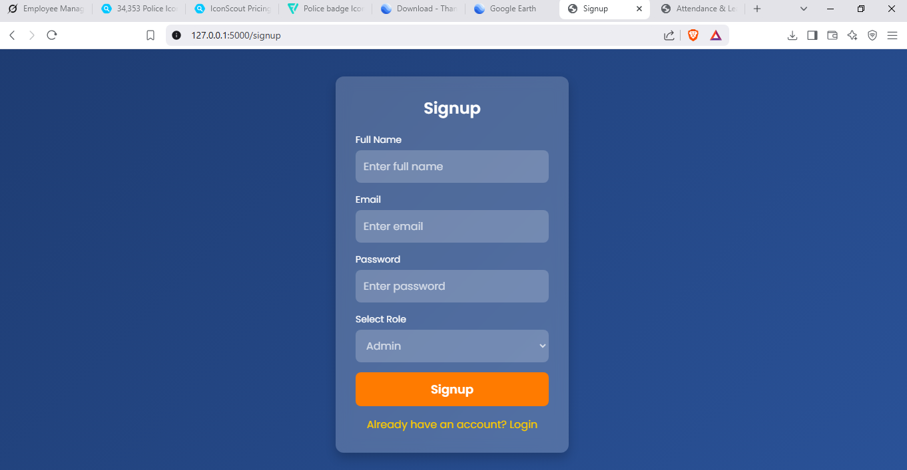

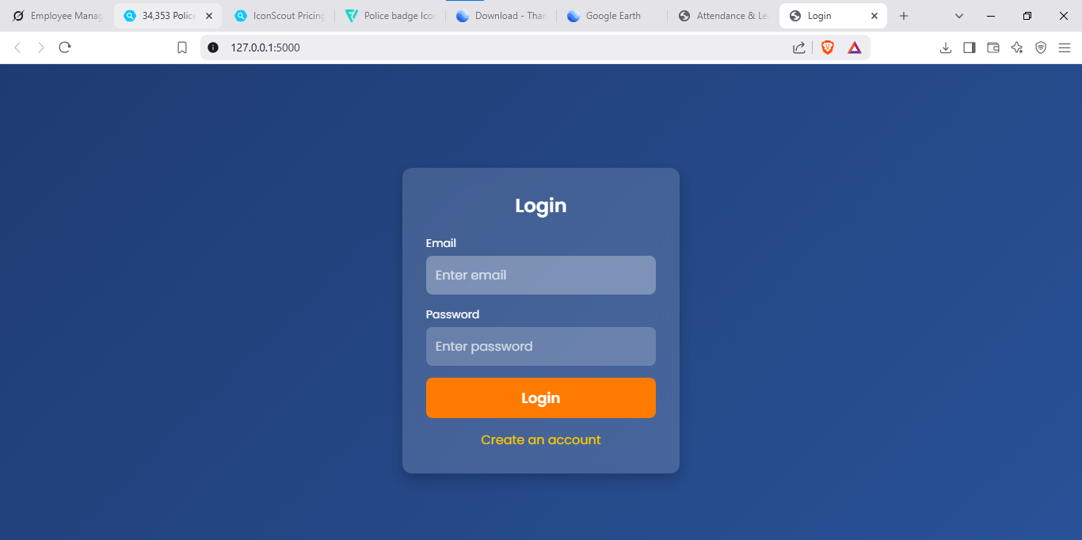

Developed the employee profile management interface.

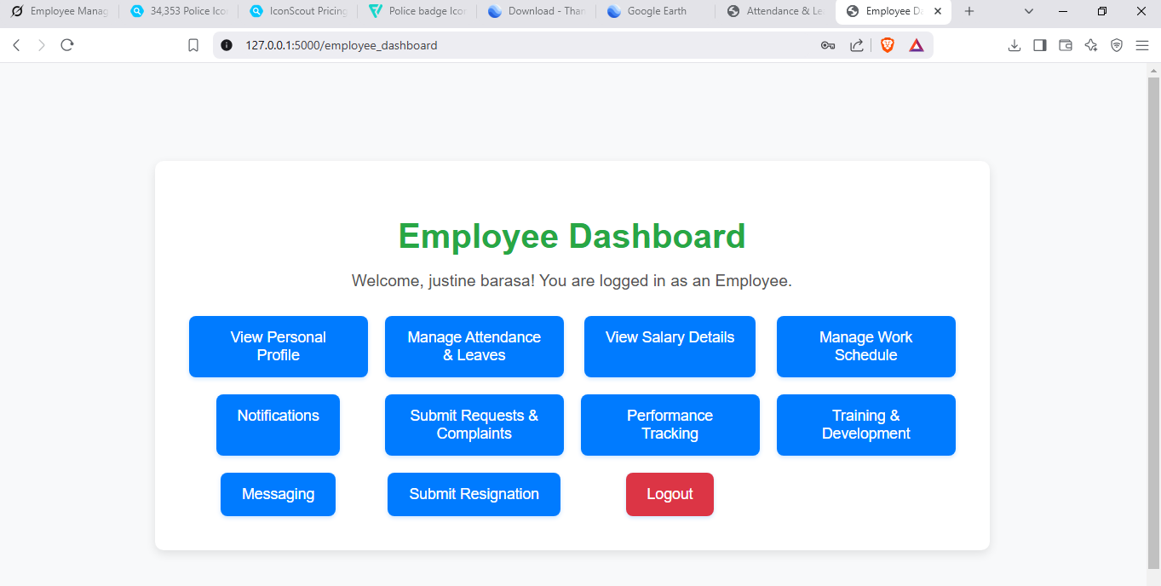

Designed an interactive dashboard for HR personnel.

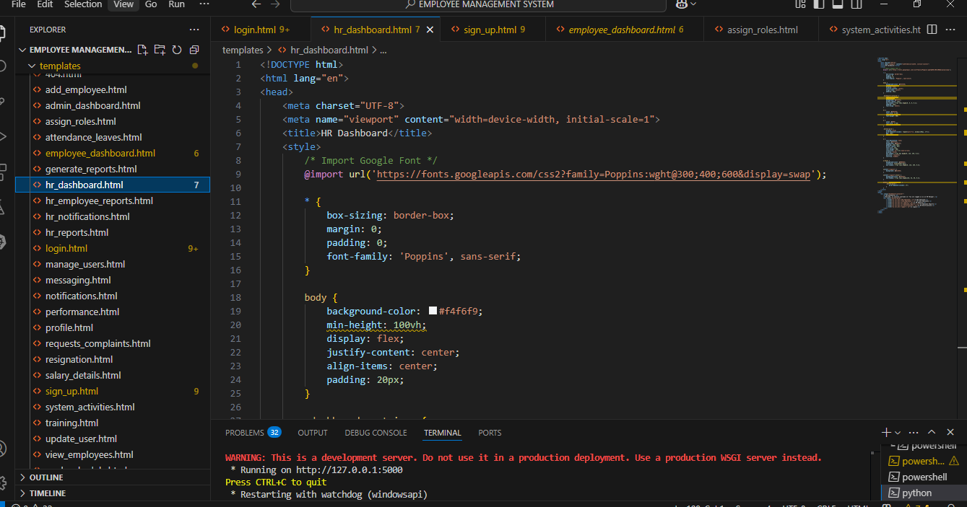

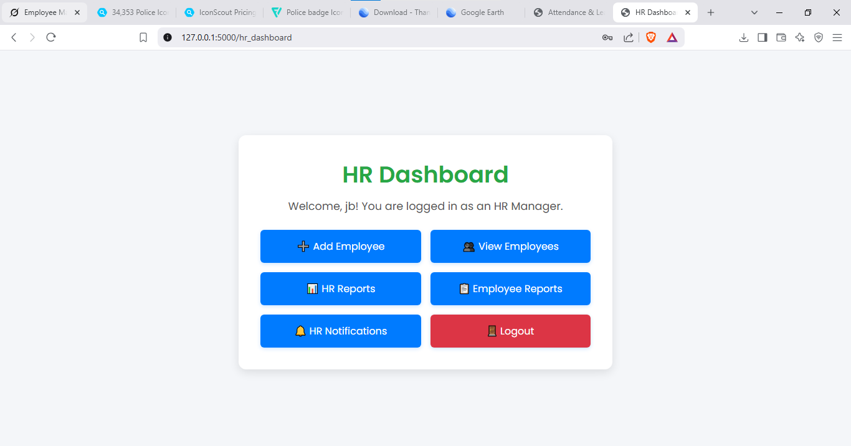

Admin dashboard layout

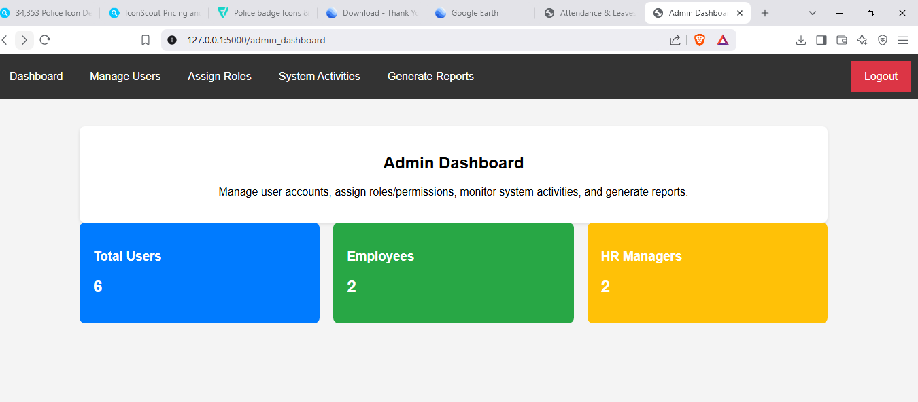

**2. Backend Development**

Created a MongoDB database with collections for employees, attendance, and performance.

Defined database schemas and relationships.

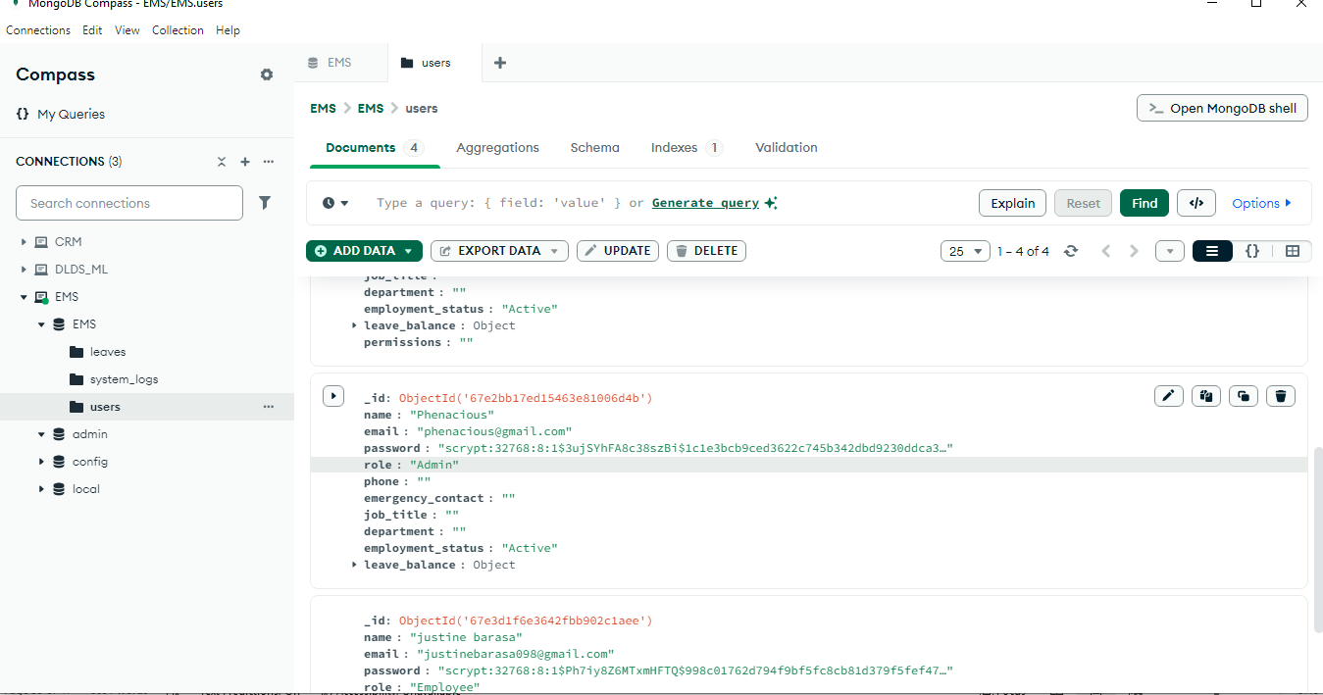

**Coding Standards and Practices**

TO ensure high code quality, maintainability, and efficiency, the following coding standards and best practices were adhered to:

#### **Clean Code Principles**

1. **Readable Code -** Used meaningful variable and function names to improve readability.
2. **Modular Design -** Broke down the system into reusable functions and modules.
3. **Consistent Formatting -** Followed proper indentation and used linters (ESLint) to enforce styling consistency.

#### **Code Review Process**

1. **Version Control with Git -** All changes were committed with meaningful messages and reviewed before merging.
2. **Peer Code Reviews -** Collaborators reviewed each other's code for efficiency and best practices.
3. **Unit Testing -** Conducted automated tests to verify code functionality before deployment.

## **4.4 Testing and Quality Assurance**

Ensuring the reliability, functionality, and security of the Employee Management System (EMS) was a key priority. A structured approach to testing and quality assurance was implemented to identify and resolve issues before deployment.

### **Testing Strategy**

To verify the system's integrity and performance, the following testing methodologies were used:

**Unit Testing**

* 1. Each individual module (e.g., employee record management, attendance tracking) was tested separately to ensure correctness.

**Integration Testing**

i. Verified that different components (frontend, backend, and database) functioned together seamlessly.

**System Testing**

* 1. The system was tested as a whole to check if it met functional and performance requirements.
  2. Conducted load testing to assess performance under high user traffic.

**User Acceptance Testing (UAT)**

* 1. Conducted testing with end-users (HR personnel and managers) to gather feedback and ensure the system met business requirements.
  2. Users interacted with the system and provided insights on usability and improvements.

### **Quality Assurance (QA)**

To maintain system quality, several QA measures were implemented:

**Functional and Non-Functional Testing**

* + 1. Ensured the system meets all specified requirements, including speed, responsiveness, and security.

**Bug Tracking and Issue Management**

i. Used **GitHub Issues** to log and track bugs, ensuring that all reported issues were systematically addressed. Regular code reviews were conducted to maintain high code quality.

## **4.5 Deployment Plan**

The deployment of the Employee Management System is carried out on a local server to ensure a controlled environment for system hosting, accessibility, and maintenance. The local server setup enables efficient data management, secure internal access, and seamless integration with organizational workflows.

### **Deployment Approach**

The deployment process follows a **phased approach** to minimize disruptions and ensure a smooth transition from development to production. The key steps include:

1. **Setting Up the Local Server -** Configuring the server with necessary software and Ensuring the server meets hardware and software requirements for optimal performance.
2. **Database Configuration -** Creating and importing the system database. Configuring user roles and permissions for database access. Setting up backup strategies for data protection.
3. **Application Deployment:**
   1. Uploading project files to the server’s root directory.
   2. Configuring environment variables and system settings.
   3. Testing application connectivity with the database.
4. **Testing & Debugging:**
   1. Conducting functional tests to verify system operations.
   2. Identifying and fixing bugs before final deployment.
5. **System Optimization & Security Measures:**
   1. Implementing security measures such as SSL certificates and firewalls.
   2. Optimizing server performance through caching and load balancing.
6. **Final Deployment & Go-Live:**
   1. Deploying the system for organizational use.
   2. Conducting training sessions for users.
   3. Monitoring the system for any post-deployment issues.

## **4.6 Go-Live Plan**

* **Transition to Production**

The transition of the Employee Management System from development to production is carefully planned to ensure a smooth deployment and minimal disruptions. The process follows a phased approach, beginning with a final pre-deployment testing phase, where the system is tested extensively on the local server to identify and resolve any remaining issues. Once testing is successfully completed, the system is officially deployed for use in the organization.

The transition timeline consists of three key phases:

1. Pre-Deployment Preparation (Week 1-2) **-** Setting up the production environment, finalizing configurations, and conducting last-minute tests.
2. Deployment and Initial Rollout (Week 3**) -** Migrating the system from the testing environment to the production server, ensuring all modules function as expected.
3. Full System Launch and Monitoring (Week 4) **-** Officially launching the system for end-users and monitoring performance closely.

## **Post-Deployment Monitoring**

After deployment, continuous monitoring is conducted to ensure optimal system performance and user satisfaction. The monitoring process includes **performance tracking, error detection, and user feedback collection**. Performance monitoring tools are configured to track system response time, server load, and database efficiency to ensure smooth operations. Any errors or system crashes are logged and resolved promptly.

User feedback is collected through surveys and direct interactions with employees to identify usability issues and areas for improvement. Based on this feedback, future system enhancements and updates will be planned. Additionally, **security logs and access controls** are monitored to detect any unauthorized access attempts, ensuring data security and compliance with organizational policies.

To support long-term system health, metrics such as **uptime percentage, system response time, and number of reported issues** are tracked regularly. The monitoring process ensures that the Employee Management System remains stable, efficient, and continuously improved to meet organizational needs.

## **4.7 Maintenance and Support**

A structured maintenance plan was established to ensure the longevity and efficiency of the system.

### **Maintenance Plan**

1. **System Updates & Patches** – Regular updates were planned to introduce new features and security patches.
2. **Performance Optimization** – Continuous improvements were made to enhance system responsiveness.
3. **Data Backups** – Regular backups were scheduled to prevent data loss in case of failures.

### **User Support**

1. **Help Desk & Support System** – A dedicated support channel was established to assist users with system-related queries.
2. **User Documentation** – A user manual was created to guide employees on system usage.
3. **Bug Reporting System** – Users could report issues directly via a built-in issue tracking module.

## **4.8 Conclusion and Future Work**

This chapter detailed the system implementation, testing strategies, deployment, and maintenance plans for the Employee Management System. Through a structured approach, the project successfully transitioned from development to real-world usage, ensuring reliability and efficiency.

### **Key Achievements**

1. Developed a fully functional **employee record management system.**
2. Integrated an **automated attendance tracking system.**
3. Implemented **performance evaluation and reporting tools.**
4. Ensured **secure authentication and access control.**

### **Future Enhancements**

To further improve the system, the following features are proposed:

1. **Integration with Biometric Devices** – Adding fingerprint or face recognition for attendance tracking.
2. **Payroll Management Module** – Automating salary computation based on attendance and performance.
3. **Mobile Application Development** – Expanding system access through a mobile-friendly application.
4. **AI-based Performance Analysis** – Using machine learning to provide predictive analytics on employee performance trends.

## **REFERENCES**

Adelakun, O., & Yekini, O. T. (2019). Employee Management System for Workforce Efficiency. International Journal of Computer Science and Information Technology (IJCSIT*)*, 11(3), 45-57.

Alomari, S., & Abushariah, M. A. (2021). A Web-Based Employee Management System Using PHP and MySQL. International Journal of Advanced Computer Science and Applications (IJACSA), 12(6), 78-85.

Batra, S., & Tyagi, S. (2020). A Cloud-Based Employee Management System: A Case Study of IT Organizations. Journal of Software Engineering and Applications (JSEA), 13(9), 91-102.

Gupta, R., & Sharma, P. (2018). Automation of Employee Records Using a Web-Based Employee Management System. International Journal of Computer Applications (IJCA), 180(24), 22-30.

Henderson, P., & Venkatraman, N. (2019). Strategic Alignment Model for Employee Performance Management Systems. Journal of Business Research (JBR), 15(4), 101-117.

Jones, D., & Williams, L. (2021). A Comparative Study of HR Management Systems and Their Effectiveness in Modern Organizations. Journal of Organizational Management (JOM), 27(2), 55-72.

Kumar, N., & Verma, R. (2022). The Role of Artificial Intelligence in Employee Performance Monitoring. International Journal of Emerging Technologies in Computing (IJETC), 5(1), 38-49.

Mishra, R., & Singh, A. (2019). Database Design and Optimization for Employee Management Systems. International Journal of Data Science (IJDS), 4(3), 67-82.

Nguyen, T., & Tran, H. (2020). Security Challenges in Employee Management Systems and Mitigation Strategies. Journal of Cybersecurity Research (JCR), 9(5), 112-130.

Smith, J. A., & Brown, M. (2020). Enhancing Workplace Productivity with an Employee Management System. Journal of Business and Technology (JBT), 8(5), 120-136.

U.S. Department of Labor. (2018). Workplace Regulations and Compliance for Employee Management. Government Printing Office.

# **APPENDICES**

## **Appendix I: Data Collection Tools**

To gather relevant data for the development of the Employee Management System, various data collection tools were utilized. These tools include:

1. **Interviews** – Structured interviews were conducted with HR personnel, managers, and employees to understand the existing employee management processes and identify key system requirements.
2. **Surveys and Questionnaires** – Online and paper-based surveys were distributed to employees to collect insights on the challenges faced with current management systems and expectations from the new system.
3. **Observation** – Direct observation of current employee record-keeping and attendance tracking methods helped identify inefficiencies and areas that needed automation.
4. **Document Analysis** – Existing employee records, payroll reports, and attendance logs were reviewed to determine necessary data fields and system functionalities.

## **Appendix II: Project Schedule**

The project schedule outlines the key phases, tasks, and timelines for the development and implementation of the Employee Management System.

**Project Timeline Overview**

|  |  |  |  |
| --- | --- | --- | --- |
| **Phase** | **Tasks** | **Duration** | **Timeline** |
| **Requirement Analysis** | Data collection, system requirements documentation | 2 weeks | January 1- January 10 |
| **System Design** | Creating architectural design, database schema, UI wireframes | 3 weeks | January 11 – January 26 |
| System Development | Frontend and backend development, database integration, and API implementation | 5 weeks | January 27 – February 20 |
| Testing and Debugging | Unit testing, integration testing, and system testing | weeks | February 21 – March 3 |
| Deployment Preparation | Final adjustments, user training, and documentation | 1 week | March 4 - March 11 |
| System Deployment | Deploying the system on a local server, monitoring performance | 2 days | March 12 – March 13 |
| Post-Deployment Support | Bug fixing, updates, and user feedback collection | Ongoing | March 15 |